Experiment No: 02

Date: 23-07-2025

EDA – Data Import and Export

**Aim:** To import data from various sources, handle different formats, and export a DataFrame to an Excel file using Python.

**Code:**

# Step 1: Import libraries import pandas as pd import sqlite3

from bs4 import BeautifulSoup import requests from io import StringIO

# Step 2: Importing data from CSV csv_data = pd.read_csv("sample.csv") print("CSV Data:") print(csv_data.head())

# Step 3: Importing data from Excel excel_data = pd.read_excel("sample.xlsx") print("\nExcel Data:")

print(excel_data.head())

# Step 4: Importing data from SQL Database # (Creating temporary database and table for demo) conn = sqlite3.connect(":memory:") # In-memory DB csv_data.to_sql("students", conn, index=False, if_exists="replace") sql_data = pd.read_sql("SELECT * FROM students", conn) print("\nSQL Data:") print(sql_data.head())

#web scraping # URL url =

"https://en.wikipedia.org/wiki/List_of_countries_by_population_(United_Nati ons)"

# Add headers to avoid blocking headers =

{"User-Agent": "Mozilla/5.0"} response = requests.get(url, headers=headers)

# Parse HTML

soup = BeautifulSoup(response.text, "html.parser")

# Find all tables with 'wikitable' class

tables_html = soup.find_all("table", {"class": "wikitable"})

print(f"Number of tables found: {len(tables_html)}")

# Convert the first one into DataFrame if tables_html:

tables = pd.read_html(StringIO(str(tables_html[0]))) web_data = tables[0] print("Web Scraped Data:") print(web_data.head()) else: print("No tables found on the page.")

print("Web Scraped Data:") print(web_data.head(2))

# Step 6: Export DataFrame to Excel

csv_data.to_excel("exported_data.xlsx", index=False) print("\nData exported successfully to 'exported_data.xlsx'") **OUTPUT:**

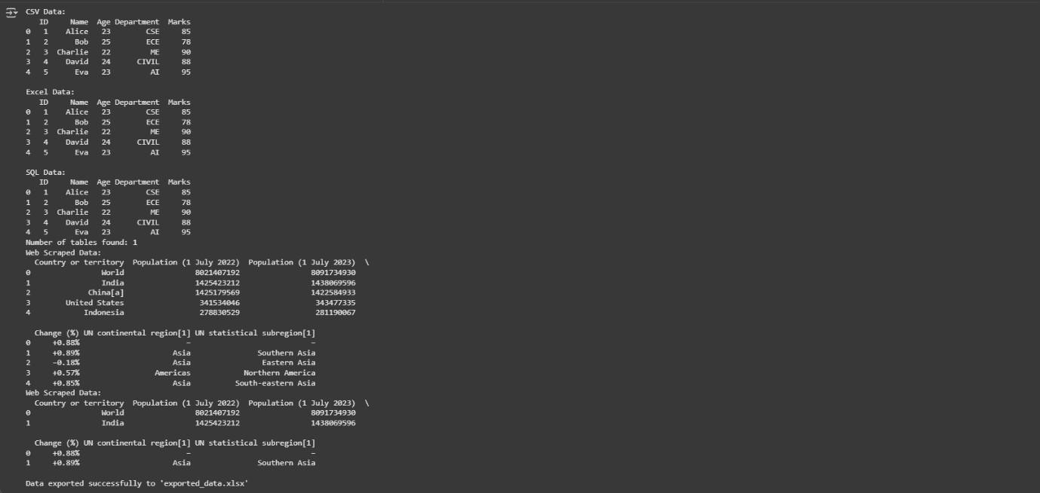

**Result:** Successfully imported data from CSV, Excel, SQL, and web sources, handled multiple formats, and exported a DataFrame to Excel.